Lab Experiment #3

ECE 282 - 002

Friday PM Lab

Carlos Sanchez and Connor Raasch

**Laboratory Experiment #3**

1. Work ‘Supplement to Experiment 2’ on p.600. Enter files found for HDL Example 3.3 on pp.130 and 132. You will use ‘Project Navigator’ to compile and simulate the circuit. Demonstrate your simulation to the TA. It should be similar to that shown in Fig. 3.38 on p.133. Include a copy of your Verilog files and simulation in your report.

timescale 1ns / 1ps

//////////////////////////////////////////////////////////////////////////////////

// Company:

// Engineer: Connor Raasch

//

// Create Date: 13:00:12 10/05/2018

// Design Name:

// Module Name: and_or_prop_delay

// Project Name:

// Target Devices:

// Tool versions:

// Description:

//

// Dependencies:

//

// Revision:

// Revision 0.01 - File Created

// Additional Comments:

//

//////////////////////////////////////////////////////////////////////////////////

module and_or_prop_delay(D,E,A,B,C);

input A,B,C;

output D,E;

wire w1;

and #30 G1(w1,A,B);

not #10 G2(E,C);

or #20 G3(D,w1,E);

endmodule

`timescale 1ns / 1ps

////////////////////////////////////////////////////////////////////////////////

// Company:

// Engineer: Connor Raasch

//

// Create Date: 13:07:33 10/05/2018

// Design Name: and_or_prop_delay

// Module Name: E:/ECE 282 lab/Lab3Part1/and_or_prop_delay_tb.v

// Project Name: Lab3Part1

// Target Device:

// Tool versions:

// Description:

//

// Verilog Test Fixture created by ISE for module: and_or_prop_delay

//

// Dependencies:

//

// Revision:

// Revision 0.01 - File Created

// Additional Comments:

//

////////////////////////////////////////////////////////////////////////////////

module and_or_prop_delay_tb;

wire D,E;

reg A,B,C;

and_or_prop_delay UUT (D, E, A, B, C);

initial begin

A = 1'b0; B = 1'b0; C=1'b0;

#100 A = 1'b1; B = 1'b1; C=1'b1;

end

initial #200 $finish;

endmodule

`timescale 1ns / 1ps

//////////////////////////////////////////////////////////////////////////////////

// Company:

// Engineer: Carlos Sanchez

//

// Create Date: 16:04:56 10/16/2018

// Design Name:

// Module Name: and_or_prop_delay

// Project Name:

// Target Devices:

// Tool versions:

// Description:

//

// Dependencies:

//

// Revision:

// Revision 0.01 - File Created

// Additional Comments:

// ECE 282 - 002

//

//////////////////////////////////////////////////////////////

module and_or_prop_delay(D,E,A,B,C);

input A,B,C;

output D,E;

wire w1;

and #30 G1(w1,A,B);

not #10 G2(E,C);

or #20 G3(D,w1,E);

endmodule

`timescale 1ns / 1ps

//////////////////////////////////////////////////////////////////////////////////

// Company:

// Engineer: Carlos Sanchez

//

// Create Date: 16:04:56 10/16/2018

// Design Name:

// Module Name: and_or_prop_delay

// Project Name:

// Target Devices:

// Tool versions:

// Description:

//

// Dependencies:

//

// Revision:

// Revision 0.01 - File Created

// Additional Comments:

// ECE 282 - 002

//

//////////////////////////////////////////////////////////////

module and_or_prop_delay_tb;

wire D,E;

reg A,B,C;

and_or_prop_delay UUT (D, E, A, B, C);

initial begin

A = 1'b0; B = 1'b0; C=1'b0;

#100 A = 1'b1; B = 1'b1; C=1'b1;

end

initial #200 $finish;

endmodule

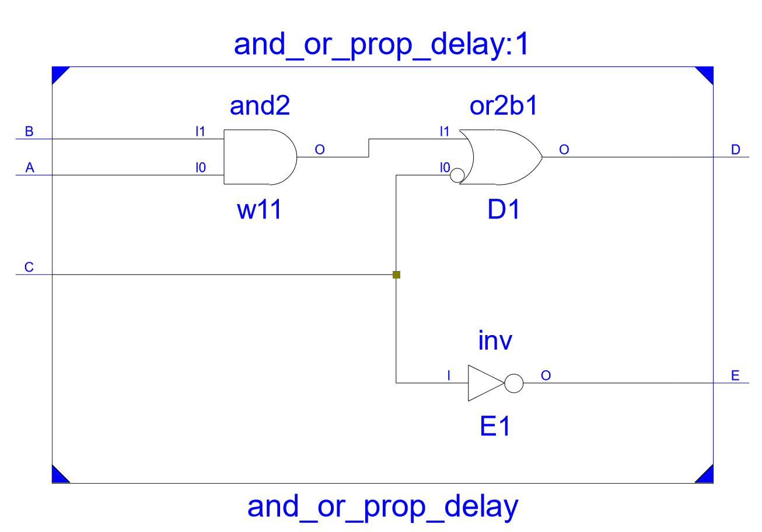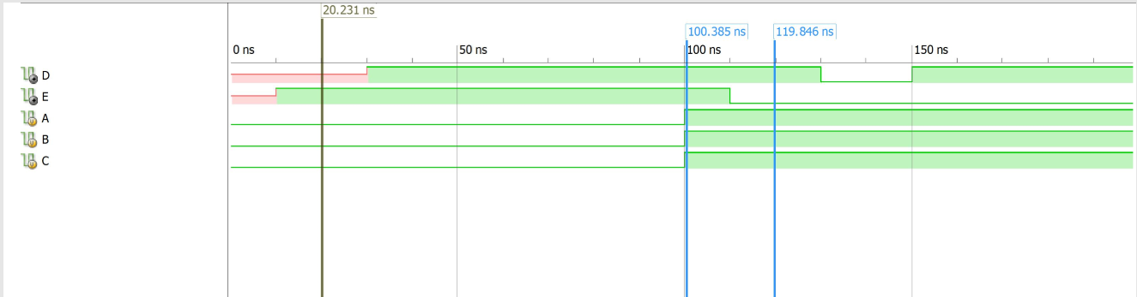

2. Continue with ‘Supplement to Experiment 2’ by working parts a, b and c. The length of the simulation should be from t=0 to t=120ns instead of what is shown in the text. Demonstrate your simulation to the TA. Include a copy of your Verilog files and simulation in your report.

`timescale 1ns / 1ps

//////////////////////////////////////////////////////////////////////////////////

// Company:

// Engineer: Connor Raasch

//

// Create Date: 16:33:09 10/09/2018

// Design Name:

// Module Name: XOR_gate

// Project Name:

// Target Devices:

// Tool versions:

// Description:

//

// Dependencies:

//

// Revision:

// Revision 0.01 - File Created

// Additional Comments:

//

//////////////////////////////////////////////////////////////////////////////////

module xor_and_or_not(F,X,Y)

input X,Y;

output F;

wire w1,w2,w3,w4;

not #10 G1(w1,x);

not #10 G2(w2,y);

and #20 G3(w3,x,w2);

and #20 G4(w4,y,w1);

or #30 G5 (F,w3,w4);

endmodule

`timescale 1ns / 1ps

////////////////////////////////////////////////////////////////////////////////

// Company:

// Engineer: Connor Raasch

//

// Create Date: 16:40:21 10/09/2018

// Design Name: XOR_gate

// Module Name: E:/Lab3Part2/XOR_gate_tb.v

// Project Name: Lab3Part2

// Target Device:

// Tool versions:

// Description:

//

// Verilog Test Fixture created by ISE for module: XOR_gate

//

// Dependencies:

//

// Revision:

// Revision 0.01 - File Created

// Additional Comments:

//

////////////////////////////////////////////////////////////////////////////////

module XOR_gate_tb;

reg x, y;

wire Out;

XOR_gate UUT (Out, x, y);

initial

begin

{x, y} = 0; #50;

{x, y} = 1; #50;

end

initial #120 $finish;

Endmodule

`timescale 1ns / 1ps

//////////////////////////////////////////////////////////////////////////////////

// Company:

// Engineer: Carlos Sanchez

//

// Create Date: 15:44:16 10/16/2018

// Design Name:

// Module Name: XOR_gate

// Project Name:

// Target Devices:

// Tool versions:

// Description:

//

// Dependencies:

//

// Revision:

// Revision 0.01 - File Created

// Additional Comments:

// ECE 282 - 002

//

//////////////////////////////////////////////////////////////

module xor_and_or_not(F,A,B)

input A,B;

output F;

wire w1,w2,w3,w4;

not #10 G1(w1,A);

not #10 G2(w2,B);

and #20 G3(w3,A,w2);

and #20 G4(w4,B,w1);

or #30 G5 (F,w3,w4);

endmodule

`timescale 1ns / 1ps

//////////////////////////////////////////////////////////////////////////////////

// Company:

// Engineer: Carlos Sanchez

//

// Create Date: 15:54:10 10/16/2018

// Design Name:

// Module Name: XOR_gate

// Project Name:

// Target Devices:

// Tool versions:

// Description:

//

// Dependencies:

//

// Revision:

// Revision 0.01 - File Created

// Additional Comments:

// ECE 282 - 002

//

//////////////////////////////////////////////////////////////

module XOR_gate_tb;

reg A, B;

wire F;

XOR_gate UUT (F, A, B);

initial

begin

{A, B} = 0; #50;

{A, B} = 1; #50;

end

initial #120 $finish;

endmodule

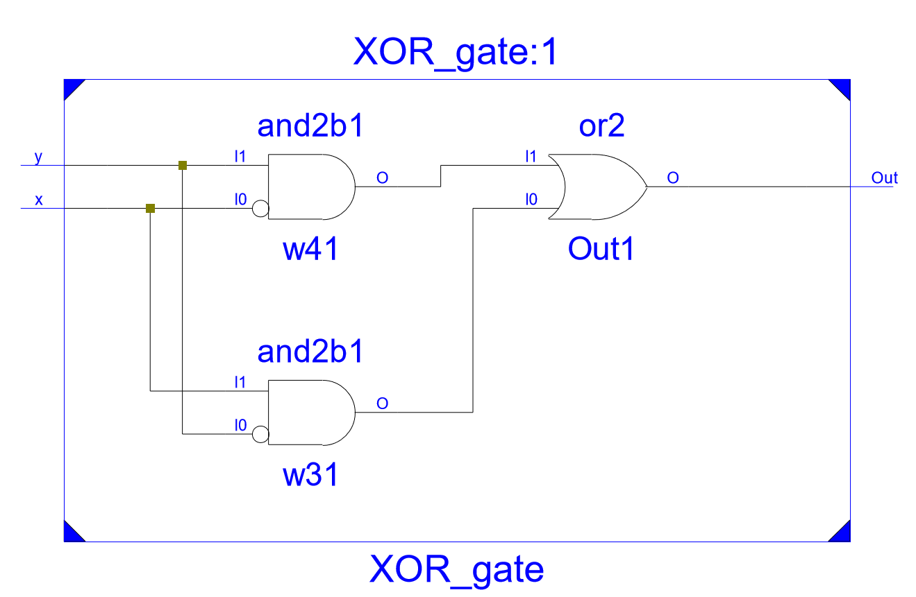

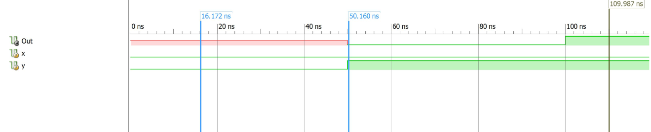

3. Work ‘Supplement to Experiment 4’ part a on p.601. Compile and simulate HDL Example 4.10 on p.219. Demonstrate your simulation to the TA showing that it provides the truth table for the circuit. Include a copy of your Verilog files and simulation in your report.

`timescale 1ns / 1ps

//////////////////////////////////////////////////////////////////////////////////

// Company:

// Engineer: Connor Raasch

//

// Create Date: 17:01:09 10/09/2018

// Design Name:

// Module Name: Mulitplex_4x1

// Project Name:

// Target Devices:

// Tool versions:

// Description:

//

// Dependencies:

//

// Revision:

// Revision 0.01 - File Created

// Additional Comments:

//

//////////////////////////////////////////////////////////////////////////////////

module Mulitplex_4x1(m_out, in_0, in_1, in_2, in_3, select);

input in_0, in_1, in_2, in_3;

input [1:0] select;

output reg m_out;

always @(in_0, in_1, in_2, in_3, select)

case (select)

2'b00: m_out<=in_0;

2'b01: m_out<=in_1;

2'b10: m_out<=in_2;

2'b11: m_out<=in_3;

endcase

endmodule

---------------------------------------------------------------------------------------------------------------------

`timescale 1ns / 1ps

////////////////////////////////////////////////////////////////////////////////

// Company:

// Engineer: Connor Raasch

//

// Create Date: 17:16:40 10/09/2018

// Design Name: Mulitplex_4x1

// Module Name: E:/Lab3Part3/Mulitplex_4x1_tb.v

// Project Name: Lab3Part3

// Target Device:

// Tool versions:

// Description:

//

// Verilog Test Fixture created by ISE for module: Mulitplex_4x1

//

// Dependencies:

//

// Revision:

// Revision 0.01 - File Created

// Additional Comments:

//

////////////////////////////////////////////////////////////////////////////////

module Mulitplex_4x1_tb;

reg in_0, in_1, in_2, in_3;

reg [1:0] select;

wire m_out;

Mulitplex_4x1 UUT (m_out, in_0, in_1, in_2, in_3, select);

initial

begin

in_0 = 1'b1; in_1 = 1'b0; in_2 = 1'b0; in_3 = 1'b0; select = 2'b00; #10;

in_0 = 1'b0; in_1 = 1'b1; in_2 = 1'b0; in_3 = 1'b0; select = 2'b01; #10;

in_0 = 1'b0; in_1 = 1'b0; in_2 = 1'b1; in_3 = 1'b0; select = 2'b10; #10;

in_0 = 1'b0; in_1 = 1'b0; in_2 = 1'b0; in_3 = 1'b1; select = 2'b11; #10;

end

initial #40 $finish;

Endmodule

---------------------------------------------------------------------------------------------------------------------

`timescale 1ns / 1ps

//////////////////////////////////////////////////////////////////////////////////

// Company:

// Engineer: Carlos Sanchez

//

// Create Date: 18:14:50 10/16/2018

// Design Name:

// Module Name: and_or_prop_delay

// Project Name:

// Target Devices:

// Tool versions:

// Description:

//

// Dependencies:

//

// Revision:

// Revision 0.01 - File Created

// Additional Comments:

// ECE 282 - 002

//

//////////////////////////////////////////////////////////////

module Mulitplex_4x1(m_out, in_0, in_1, in_2, in_3, select);

input in_0, in_1, in_2, in_3;

input [1:0] select;

output reg m_out;

always @(in_0, in_1, in_2, in_3, select)

case (select)

2'b00: m_out<=in_0;

2'b01: m_out<=in_1;

2'b10: m_out<=in_2;

2'b11: m_out<=in_3;

endcase

Endmodule

---------------------------------------------------------------------------------------------------------------------

`timescale 1ns / 1ps

//////////////////////////////////////////////////////////////////////////////////

// Company:

// Engineer: Carlos Sanchez

//

// Create Date: 18:16:36 10/16/2018

// Design Name:

// Module Name: Mulitplex_4x1

// Project Name:

// Target Devices:

// Tool versions:

// Description:

//

// Dependencies:

//

// Revision:

// Revision 0.01 - File Created

// Additional Comments:

// ECE 282 - 002

//

//////////////////////////////////////////////////////////////

module Mulitplex_4x1_tb;

reg in_0, in_1, in_2, in_3;

reg [1:0] select;

wire m_out;

Mulitplex_4x1 UUT (m_out, in_0, in_1, in_2, in_3, select);

initial

begin

in_0 = 1'b1; in_1 = 1'b0; in_2 = 1'b0; in_3 = 1'b0; select = 2'b00; #10;

in_0 = 1'b0; in_1 = 1'b1; in_2 = 1'b0; in_3 = 1'b0; select = 2'b01; #10;

in_0 = 1'b0; in_1 = 1'b0; in_2 = 1'b1; in_3 = 1'b0; select = 2'b10; #10;

in_0 = 1'b0; in_1 = 1'b0; in_2 = 1'b0; in_3 = 1'b1; select = 2'b11; #10;

end

initial #40 $finish;

endmodule

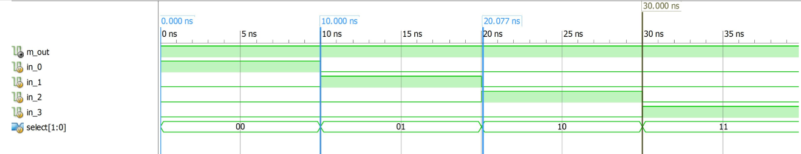

4. Continue with ‘Supplement to Experiment 4’ part b on p.602. Use Verilog to compile and simulate the three-input Majority Circuit that was completed in the pre-lab. Demonstrate your

simulation to the TA. Include a copy of your Verilog files and simulation in your report.

timescale 1ns / 1ps

////////////////////////////////////////////////////////////////////////////////

// Company:

// Engineer: Connor Raasch

//

// Create Date: 17:30:45 10/09/2018

// Design Name:

// Module Name: Majority_3x1

// Project Name:

// Target Device:

// Tool versions:

// Description:

//

// Dependencies:

//

// Revision:

// Revision 0.01 - File Created

// Additional Comments:

//

////////////////////////////////////////////////////////////////////////////////

module Majority_3x1(Out,x,y,z,)

input x,y,z;

output Out;

wire w1,w2,w3;

and G1(w1,x,z);

and G2(w2,y,z);

and G3(w3,x,y);

or G4(Out,w1,w2,w3);

endmodule

timescale 1ns / 1ps

////////////////////////////////////////////////////////////////////////////////

// Company:

// Engineer: Connor Raasch

//

// Create Date: 17:35:32 10/09/2018

// Design Name: Majority_3x1

// Module Name: E:/Lab3Part4/Majority_3x1_tb.v

// Project Name: Lab3Part4

// Target Device:

// Tool versions:

// Description:

//

// Verilog Test Fixture created by ISE for module: Majority_3x1

//

// Dependencies:

//

// Revision:

// Revision 0.01 - File Created

// Additional Comments:

//

////////////////////////////////////////////////////////////////////////////////

module Majority_3x1_tb;

reg x, y, z;

wire Out;

Majority_3x1 UUT (Out, x, y, z);

initial

begin

x = 1'b0; y = 1'b0; z = 1'b0; #10;

x = 1'b0; y = 1'b0; z = 1'b1; #10;

x = 1'b0; y = 1'b1; z = 1'b0; #10;

x = 1'b0; y = 1'b1; z = 1'b1; #10;

x = 1'b1; y = 1'b0; z = 1'b0; #10;

end

initial #70 $finish;

endmodule

---------------------------------------------------------------------------------------------------------------------

`timescale 1ns / 1ps

//////////////////////////////////////////////////////////////////////////////////

// Company:

// Engineer: Carlos Sanchez

//

// Create Date: 17:03:26 10/16/2018

// Design Name:

// Module Name: Majority_3x1

// Project Name:

// Target Devices:

// Tool versions:

// Description:

//

// Dependencies:

//

// Revision:

// Revision 0.01 - File Created

// Additional Comments:

// ECE 282 - 002

//

//////////////////////////////////////////////////////////////

module Majority_Circ(F,x,y,z,)

input x,y,z;

output F;

wire w1,w2,w3;

and G1(w1,x,z);

and G2(w2,y,z);

and G3(w3,x,y);

or G4(F,w1,w2,w3);

endmodule

---------------------------------------------------------------------------------------------------------------------

`timescale 1ns / 1ps

//////////////////////////////////////////////////////////////////////////////////

// Company:

// Engineer: Carlos Sanchez

//

// Create Date: 17:04:46 10/16/2018

// Design Name:

// Module Name: Majority_3x1

// Project Name:

// Target Devices:

// Tool versions:

// Description:

//

// Dependencies:

//

// Revision:

// Revision 0.01 - File Created

// Additional Comments:

// ECE 282 - 002

//

//////////////////////////////////////////////////////////////

module Majority_Circ_tb;

reg x, y, z;

wire F;

Majority_Circ UUT (F, x, y, z);

initial

begin

x = 1'b0; y = 1'b0; z = 1'b0; #10;

x = 1'b0; y = 1'b0; z = 1'b1; #10;

x = 1'b0; y = 1'b1; z = 1'b0; #10;

x = 1'b0; y = 1'b1; z = 1'b1; #10;

x = 1'b1; y = 1'b0; z = 1'b0; #10;

end

initial #70 $finish;

endmodule

